UNIVERSITY OF LONDON
GOLDSMITHS COLLEGE

B.Sc. Examination 2017

COMPUTING AND INFORMATION SYSTEMS

IS53002A Neural Networks

Duration: 2 hours 15 minutes

Date and time:

This paper is in two parts: part A and part B. You should answer ALL
questions from part A and TWO questions from part B. Part A carries
40 marks, and each question from part B carries 30 marks. The marks
for each part of a question are indicated at the end of the part in
[.] brackets.

Electronic calculators must not be programmed prior to the examination. Calculators which display graphics, text or algebraic equations are not allowed.

THIS PAPER MUST NOT BE REMOVED FROM THE EXAMINATION ROOM

Part A. Question 1.

a) i) Why do we use a learning rate parameter η when training single-layer
Perceptron networks? [2]

ii) What is the effect of using a very large learning rate η on the performance of
the training algorithm for single-layer Perceptrons? [2]

b) Consider a single-layer Perceptron with two inputs x₁, x₂ and two weights having
initial values: w₁= 0.2, and w₂= -0.1. Calculate the output that will be produced by
this Perceptron given the input vector: x₁=1.0, x₂=1.0, in each of the two cases: [7]

i) using a threshold activation function: if ( Σ_{i}(w_{i}x_{i}) ) > 0 then y = 1 else y = 0;
ii) using a sigmoidal activation function.

c) Write the expression for calculating the total number of weights and biases in
a two layer neural network with n inputs, H nodes in the hidden layer, and
k outputs. [2]

d) Define the equation of the non-linear function modelled by a two-layer Perceptron
neural network, and explain each component in it. [5]

e) In what sequence do the neurons in a feedforward neural network fire? [4]

f) Explain the formula for training multilayer neural networks using weight decay
regularization. Describe what is the purpose of weight decay regularization. [6]

g) What is the purpose of neural network ensemble averaging. Present the
boosting algorithm for training committees of neural networks. [12]

IS53002A 2017 TURN OVER
Part B. Question 2.

a) Describe briefly which network learning process is called supervised? [3]

b) i) Which of the Boolean functions, AND, OR, XOR and NOT, can be modelled
by a single-layer Perceptron with two inputs. [4]

ii) Explain briefly what is the main difference between the training rule for
sigmoidal single-layer Perceptrons and the training rule for thresholded
single-layer Perceptron networks? [6]

iii) Explain the incremental gradient descent training rule for single-layer
unthresholded Perceptron networks, and describe the meaning of every term
in the rule. [5]

b) Demonstrate incremental gradient descent training of an unthresholded Perceptron
with 3 inputs x₁, x_{2,} and x₃. Use initial weights: (w₁, w₂, w₃) = ( 0.3, –0.2, –0.1 ),
and learning rate η =0.15. Consider the following training examples:
x₁ | x₂ | x₃ | y_{T}
1.0 | –0.8 | 1.9 | 1
0.9 | –0.7 | 2.0 | 0
- Show the computation of the neuron output and the weight updates after
the first example. [6]
- Show the computation of the neuron output and the weight updates after
the second example. [6]

IS53002A 2017 TURN OVER
Part B. Question 3.

Perform training of the multilayer neural network given in the figure below. The network has two nodes: one hidden and one output node each of which uses the sigmoidal activation function. There are two inputs to the network: (x₁, x₂), and
5 weights (w₁, w₂, w₃, w₄, w₅). Train this neural network using the backpropagation algorithm with learning rate η = 1.0.
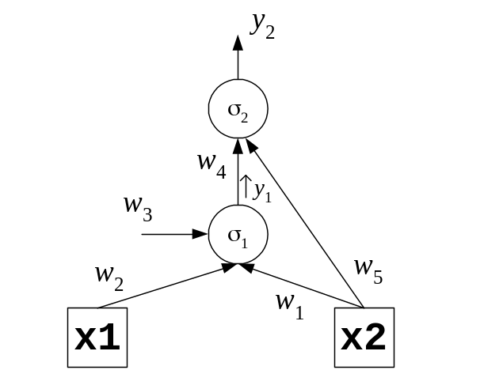

Consider the following initial weights:
w₁ = 0.1 w₂ = –0.2 w₃ = –0.15 w₄ = –0.25 w₅ = 0.3

Use the following training vector:
x₁ x₂ y
1 1 1

i) Give the node outputs calculated during the forward pass of the
backpropagation algorithm. [2x2=4]
ii) Show the calculation of the error derivatives β (beta) during the backward pass
of the backpropagation algorithm. [2x3=6]
iii) Compute the weight updates during the backward pass of the
backpropagation algorithm. [5x3=15]
iv) Show the modified weights after one iteration of the backpropagation
algorithm. [5]

IS53002A 2017 TURN OVER
Part B. Question 4.

a) i) Describe what operations are involved in the retrieval phase of the Hopfield
neural networks. [4]

ii) Explain the Widrow-Hoff training rule for Hopfield neural networks. [5]

b) Consider a simple Hopfield recurrent network with 4 neurons and 4 inputs. Let
the initial weights in this network be given with the following matrix:

0 0.15 –0.15 0.2
W = 0.15 0 0.3 –0.1
–0.15 0.3 0 –0.25
0.2 –0.1 –0.25 0
i) Compute the energy of this Hopfield network for the state: [1,1,0,1]. [4]
ii) Demonstrate that the stable state for this network is: [1,1,0,1]. [4x2=8]
iii) Show that this Hopfield network is unstable for the fourth neuron given
input vector [1,1,1,1], and retrain it. Give finally the updated weight matrix.
[2+2+2x2+1=9]

IS53002A 2017 END OF EXAMINATION

